Bees and Infrared Light
  - Can Faraday Cages Rob Bees from Infrared Light and Have Negative Consequences for Metabolism?
Mads Rohde
2025-12-08

Is infrared light important for bees?
In my most recent article (Rohde, 2025), I covered a study that had investigated the question: What happens to bees that are shielded from mobile phone radiation in Faraday cages?
The study (Favre & Johansson, 2025), with its limitations, reported a negative effect of shielding bees from mobile phone radiation, which was surprising. It led the researchers to ask if some vital factor could have been lost during the shielding.
What could that vital factor be? Not mobile phone radiation, at least (since it’s pretty safe to assume that bees have not evolved to rely on a factor introduced by humans during the last few decades). But what the study reportedly indicated, was that the negative effect of shielding bees, could be due to the loss of the Schumann frequencies, since reintroducing Schumann frequencies by artificial means, reportedly allowed the bee hive to survive without countermeasures to support its health.
But, I, on the other hand, also speculated whether another factor could be at play: Could the same shielding also block bees from beneficial infrared light from the sun, and could infrared radiation be important for bees’ health?
I based these speculations on a groundbreaking study that has found proof that infrared light from the sun passes through the human body (Jeffery et al., 2025).
Since infrared light can penetrate many materials, it might also penetrate natural bee hives and be important for bee health. However, it might be blocked to a certain extent by solid metal Faraday cages, such as the one used in the Favre & Johansson study, even if their cage was perforated (with holes).

Infrared light expert Glen Jeffery guests the Huberman Lab podcast
I would again like to point out that I know very little about the biology and physiology of bees. Still, I have come across some new information that I should share:
On 2 December, a couple of days after I had published my post (Rohde, 2025) on the honeybee/Faraday cage/Schumann resonance study (Favre & Johansson, 2025), the lead author of the recent study on infrared light passing through the human body, Glen Jeffery (2025), appeared on the Huberman Lab podcast (Andrew Huberman, 2025).
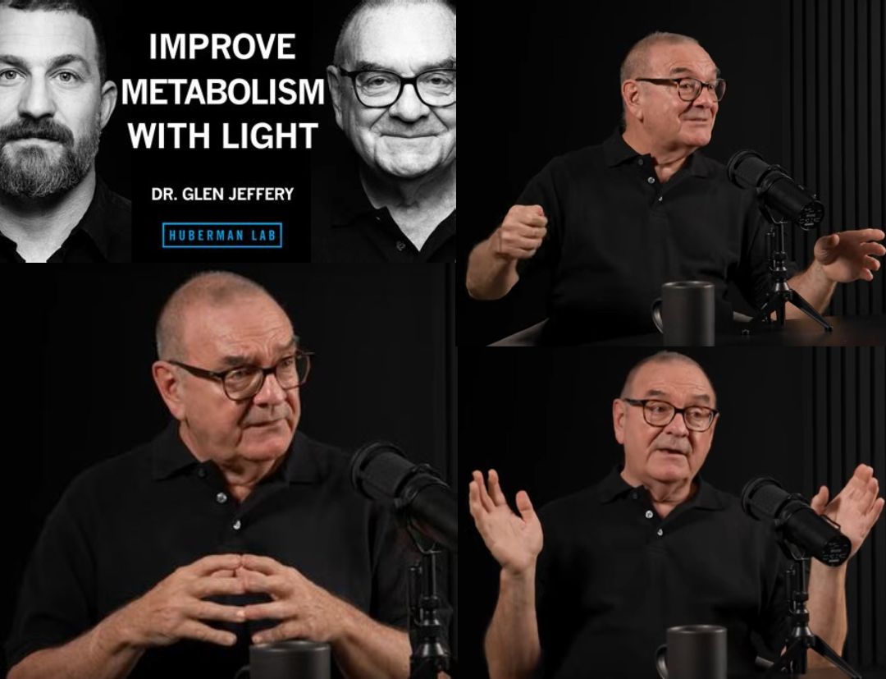
Image: An engaged Glen Jeffery at the Huberman Lab podcast in December 2025. Collage by Mads Rohde (2025), CC BY 4.0. Screenshots from the Huberman Lab podcast used under fair use.
To my amazement, it was mentioned that Glen Jeffery has actually conducted studies also on the effect of infrared or near-infrared light in bees.

Glen Jeffery’s studies on bees exposed to light
So I searched up a list of Jeffery’s studies. Below are studies I found by going to Jeffery’s profile at Semantic Scholar and searching for “bees” (my emphasis in bold text):
- From the Lab to the Field: Translating Applications of Near-Infrared Light from Laboratory to the Field to Improve Honeybee Mitochondrial Function and Hive Health (Kam et al., 2022)
- Systemic glucose levels are modulated by specific wavelengths in the solar light spectrum that shift mitochondrial metabolism (Powner & Jeffery, 2022)
- Improved mitochondrial function corrects immunodeficiency and impaired respiration in neonicotinoid exposed bumblebees (Powner et al., 2021)
- Improving Mitochondrial Function Protects Bumblebees from Neonicotinoid Pesticides (Powner et al., 2016)
Upon inspecting these studies by Jeffery and co-authors, it can be seen that they study light of 670 nm (nanometre) wavelength. They term this wavelength “near-infrared”, but I note that this wavelength actually falls in the visible spectrum (400-700 nm) (see table in Grokipedia or Wikipedia) and can be perceived as a deep red color (while infrared light starts at 700 nm)
One of Jeffery’s studies (Powner & Jeffery, 2022) does however state that other wavelengths, up to 900 nm and in the infrared spectrum, are known to be positive for cell metabolism (allow cells to produce more ATP to be used as energy):
Known wavelengths have opposing effects of photobiomodulation, with longer wavelengths (660–900 nm red/infrared) increasing ATP production, and 420 nm (blue) light suppressing metabolism.
This is how far my investigations of this corner of the literature went this time around. From this little investigation, it does however seem like Jeffery’s studies imply that the question about the potential detrimental effect of blocking bees from infrared light, is already beyond a faint idea, and closer to a sound scientific hypothesis. Thus it would be interesting to know the degree to which the Faraday cage in Favre & Johansson (2025) actually blocked a significant amount of infrared radiation from entering the bee hive.
Anyhow, below is an image from one of Jeffery’s studies (Powner & Jeffery, 2022). In this study two groups of bumblebees “[…] were starved overnight and given a glucose load in the morning. In the first group glucose levels were examined at hourly intervals. In the second group, bees were additionally exposed to either 670 nm or 420 nm light and their blood glucose examined.”
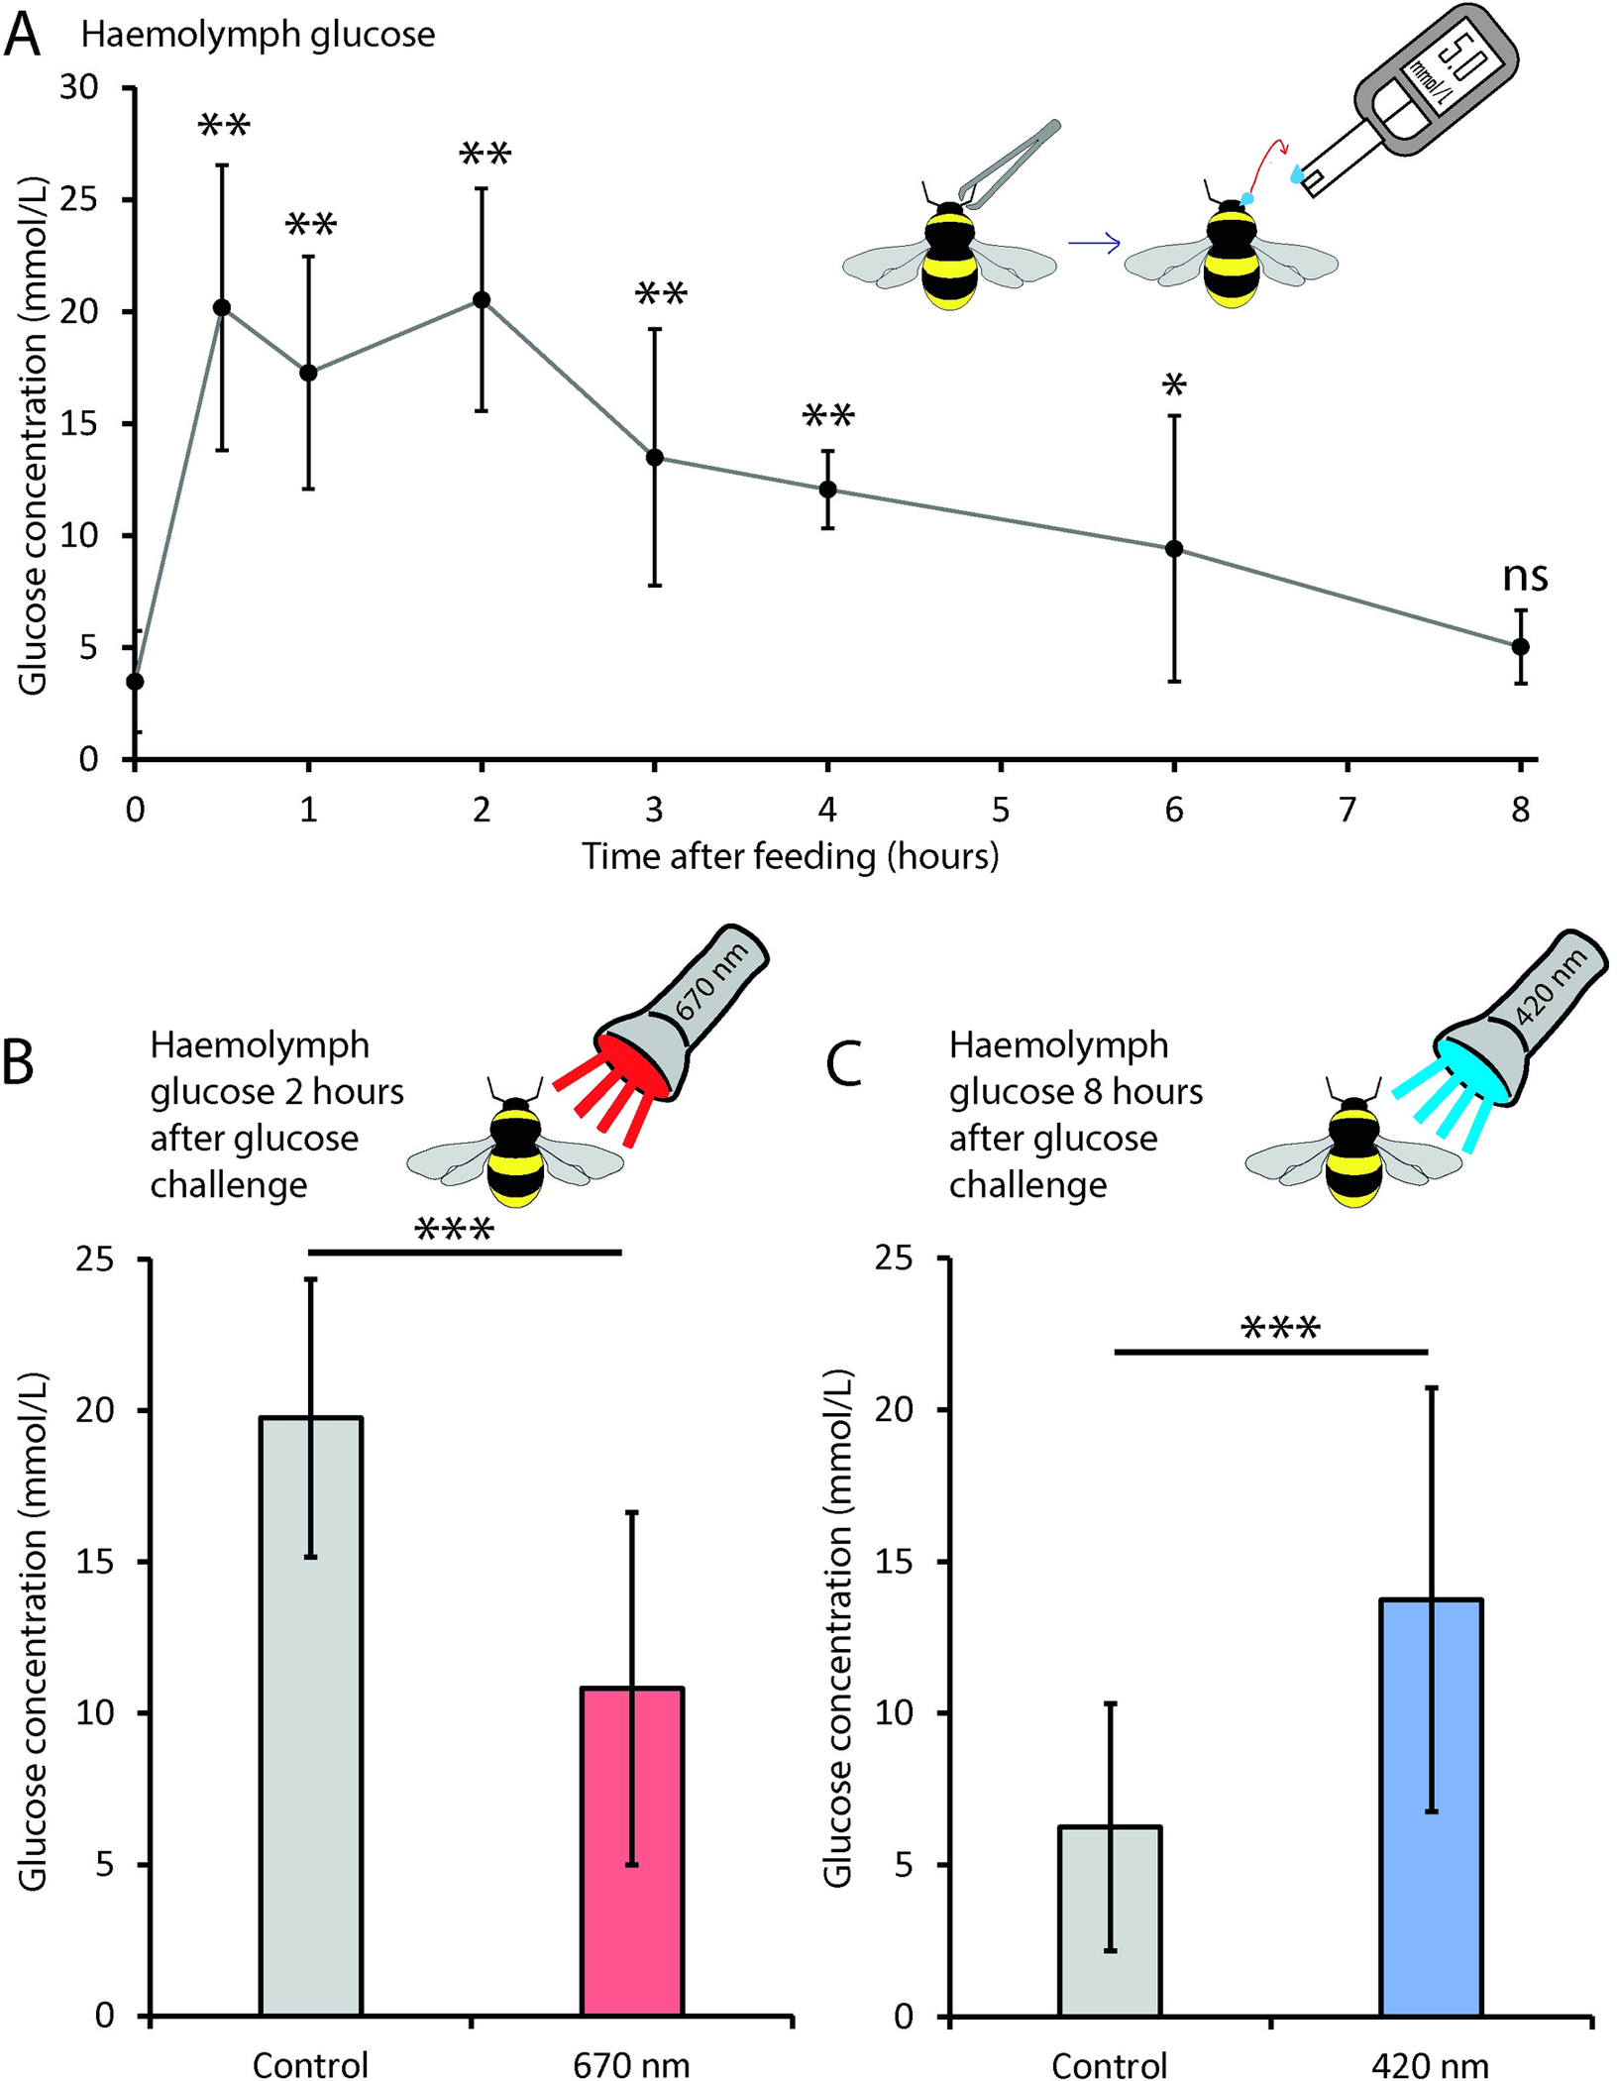
Figure from Powner & Jeffery (2022), licensed under CC BY 4.0: “Visible light controls bumblebee haemolymph glucose levels.”
The illustration shows that when bumblebees that had been starved overnight, were given the glucose load and exposed to 670 nm light (red), their glucose levels two hours after the glucose load were lower than controls that did not receive near-infrared light. An interpretation is that the light improved the bee’s metabolism (energy consumption, or consumption of sugar).
(The opposite was seen for 420 nm light (blue): instead of falling normally, glucose levels remained elevated / failed to decrease as in controls).
 The Jeffery-Huberman talk, 2 December 2025
The discussion between Glen Jeffery and Andrew Huberman, mainly centered on the potential negative impact of current lighting systems on human health. Bees were not a topic.
It was discussed that indoors light today is unbalanced, with too much light in the blue part of the spectrum and too little red light.
Jeffery raised concerns about the transformation of the indoor human light environment, after LED lights were introduced in the 2000s and gradually replaced incandescent lights.

Both, infrared light and electropollution from wireless techonology, deserves attention
To me, the most interesting part of the topic of light and infrared light, is the detrimental effects that the lack of such light may have on human health.
Humans spend more time indoors, with less exposure to natural sunlight and more exposure to artificial light sources, than we used to do throughout our evolution.
At the same time, the potential importance of full-spectrum light in biology, should not distract from the potential detrimental effects of electropollution.
Indeed, the scientific literature does underscore the importance of paying attention to electropollution when it comes to insects. Just after I published the previous article (Rohde, 2025), I was tipped about a new paper published in Frontiers in Public Health (Levitt et al., 2025).
The fresh review is titled “Flora and fauna: how nonhuman species interact with natural and man-made EMF at ecosystem levels and public policy recommendations”, and importantly states the following in the abstract, about the current levels of electromagnetic fields from human technology, that insects are exposed to:
Nowhere on Earth today is completely RF-EMF free. […] Today’s exposures are capable, even at very low intensities, of disrupting critical fauna/flora functions. Any existing exposure standards are strictly for humans.
This shows that insects populations may already be suffering. And for humans, even if exposure standards exist, the mere existence of standards is not a guarantee against detrimental effects — if such standards are founded on premises that do not hold.
In that regard, I often like to point to the fact that most human observational, epidemiological studies, indicate detrimental effects on human health of living in proximity to mobile phone base stations (Balmori, 2022). There is more to say here, but I cannot always give a full lecture.
At present, as a result of what I am learning about infrared light, I am pondering less about the detrimental effects of radiofrequency radiation alone, and more about the possible combined effect of radiofrequency radiation and too little natural lighting.

Andrew Huberman (Director). (2025, December 1). Dr. Glen Jeffery: Using Red Light to Improve Your Health & the Harmful Effects of LEDs [Video recording]. https://www.youtube.com/watch?v=iT8W6kaD-RA
Balmori, A. (2022). Evidence for a health risk by RF on humans living around mobile phone base stations: From radiofrequency sickness to cancer. Environmental Research, 214, 113851. https://doi.org/10.1016/j.envres.2022.113851
Favre, D., & Johansson, O. (2025). HONEYBEES’BEHAVIOUR IN A FARADAY-SHIELDED HIVE: MANDATORY SCHUMANN RESONANCE FOR COLONY SURVIVAL. https://diagnose-funk.ch/images/aktuelles/mandatory_schumann_frequency-Daniel_Favre-2025.pdf
Jeffery, G., Fosbury, R., Barrett, E., Hogg, C., Carmona, M. R., & Powner, M. B. (2025). Longer wavelengths in sunlight pass through the human body and have a systemic impact which improves vision. Scientific Reports, 15(1), 24435. https://doi.org/10.1038/s41598-025-09785-3
Kam, J. H., Brod, C., Gourde, A., Brod, M., & Jeffery, G. (2022). From the Lab to the Field: Translating Applications of Near-Infrared Light from Laboratory to the Field to Improve Honeybee Mitochondrial Function and Hive Health. Photobiomodulation, Photomedicine, and Laser Surgery, 40(9), 604–612. https://doi.org/10.1089/photob.2022.0025
Levitt, B. B., Lai, H. C., Manville, A. M., & Scarato, T. (2025). Flora and fauna: How nonhuman species interact with natural and man-made EMF at ecosystem levels and public policy recommendations. Frontiers in Public Health, 13. https://doi.org/10.3389/fpubh.2025.1693873
Powner, M. B., & Jeffery, G. (2022). Systemic glucose levels are modulated by specific wavelengths in the solar light spectrum that shift mitochondrial metabolism. Plos One, 17(11), e0276937. https://journals.plos.org/plosone/article?id=10.1371/journal.pone.0276937
Powner, M. B., Priestley, G., Hogg, C., & Jeffery, G. (2021). Improved mitochondrial function corrects immunodeficiency and impaired respiration in neonicotinoid exposed bumblebees. PloS One, 16(8), e0256581. https://journals.plos.org/plosone/article?id=10.1371/journal.pone.0256581
Powner, M. B., Salt, T. E., Hogg, C., & Jeffery, G. (2016). Improving mitochondrial function protects bumblebees from neonicotinoid pesticides. PloS One, 11(11), e0166531. https://journals.plos.org/plosone/article?id=10.1371/journal.pone.0166531
Rohde, M. (2025). European Scientists Gather to Discuss Electromagnetic Fields, Insects, and the Global Insect Decline: Episode II, Daniel Favre. EpiWaves Blog. https://madsrohde.com/posts/en/emf-seminar-oslo-2025-episode-2/

